**Lab1**

**Date: 05/04/2024**

**Write a python program to import and export data using Pandas library functions**

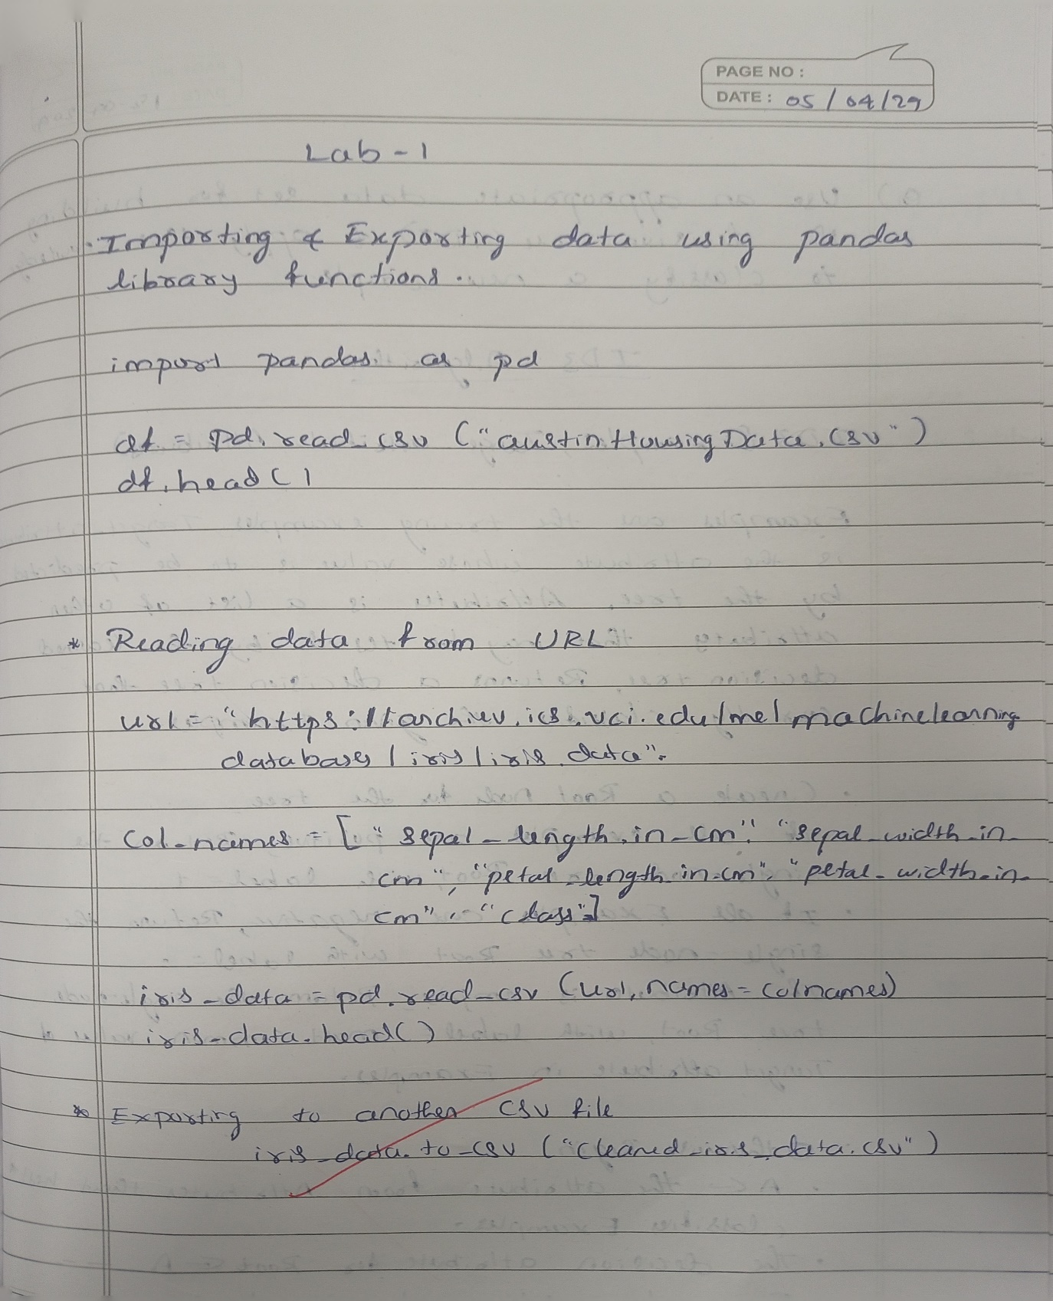

OUTPUT :

Dataset -

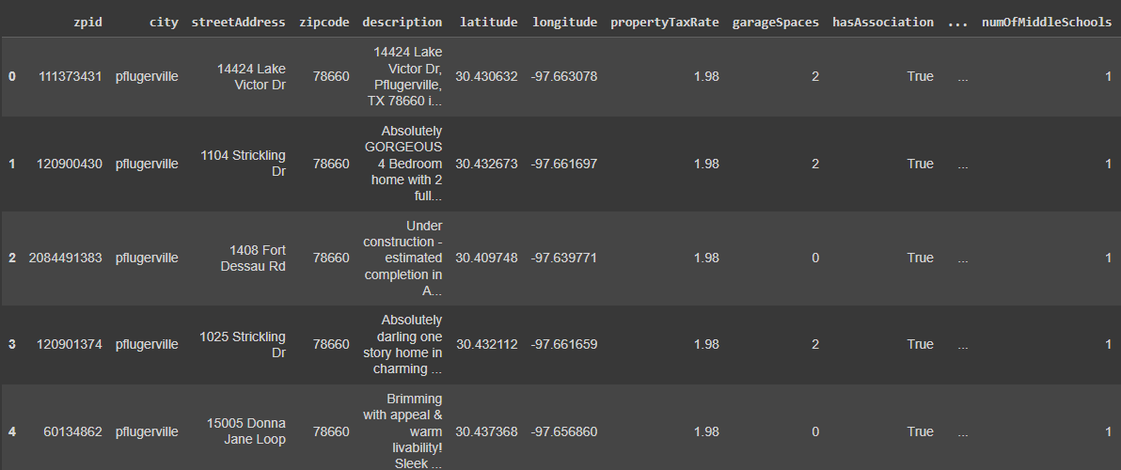

After reading dataset from URL –

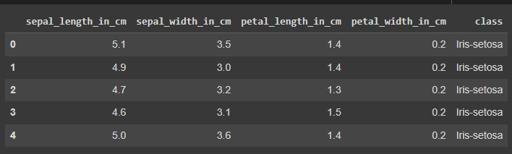

CSV file after exporting –

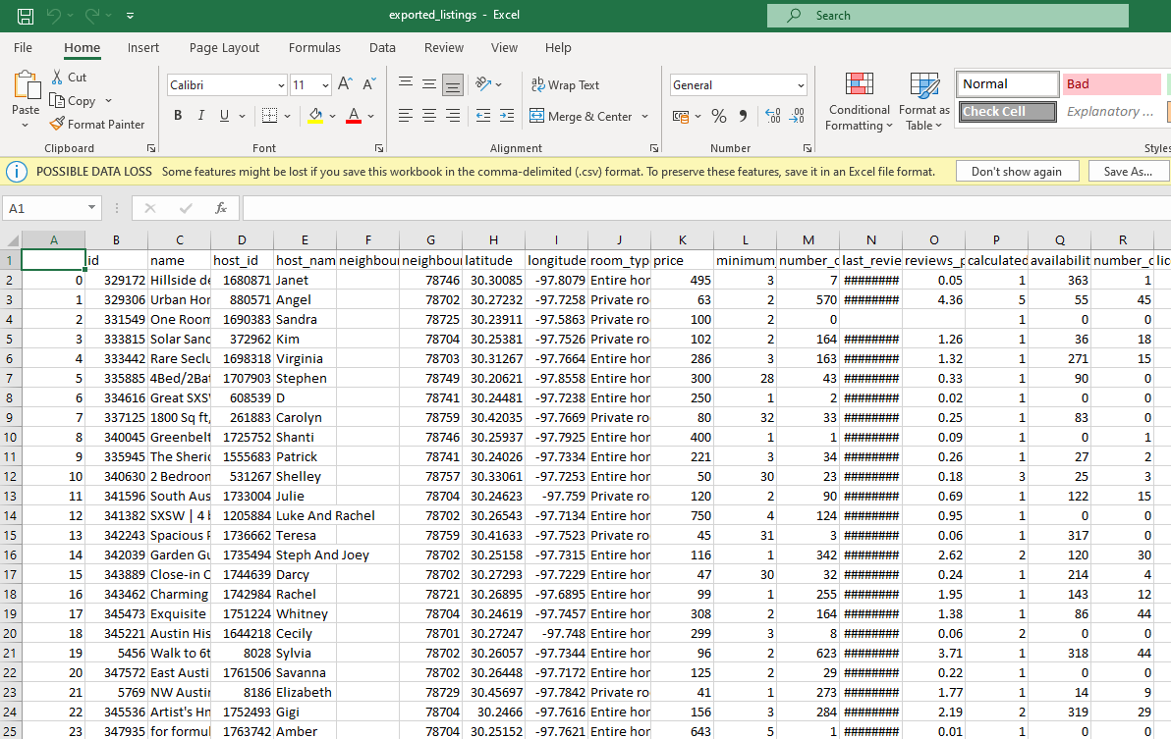

**Lab – 2**

**Use an appropriate data set for building the decision tree (ID3) and apply this knowledge to classify a new sample.**

Algorithm:

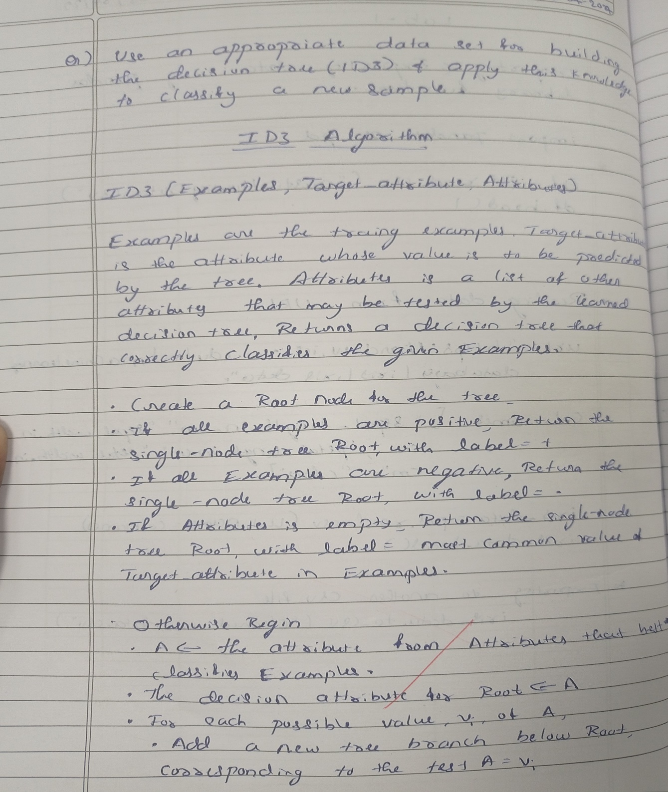

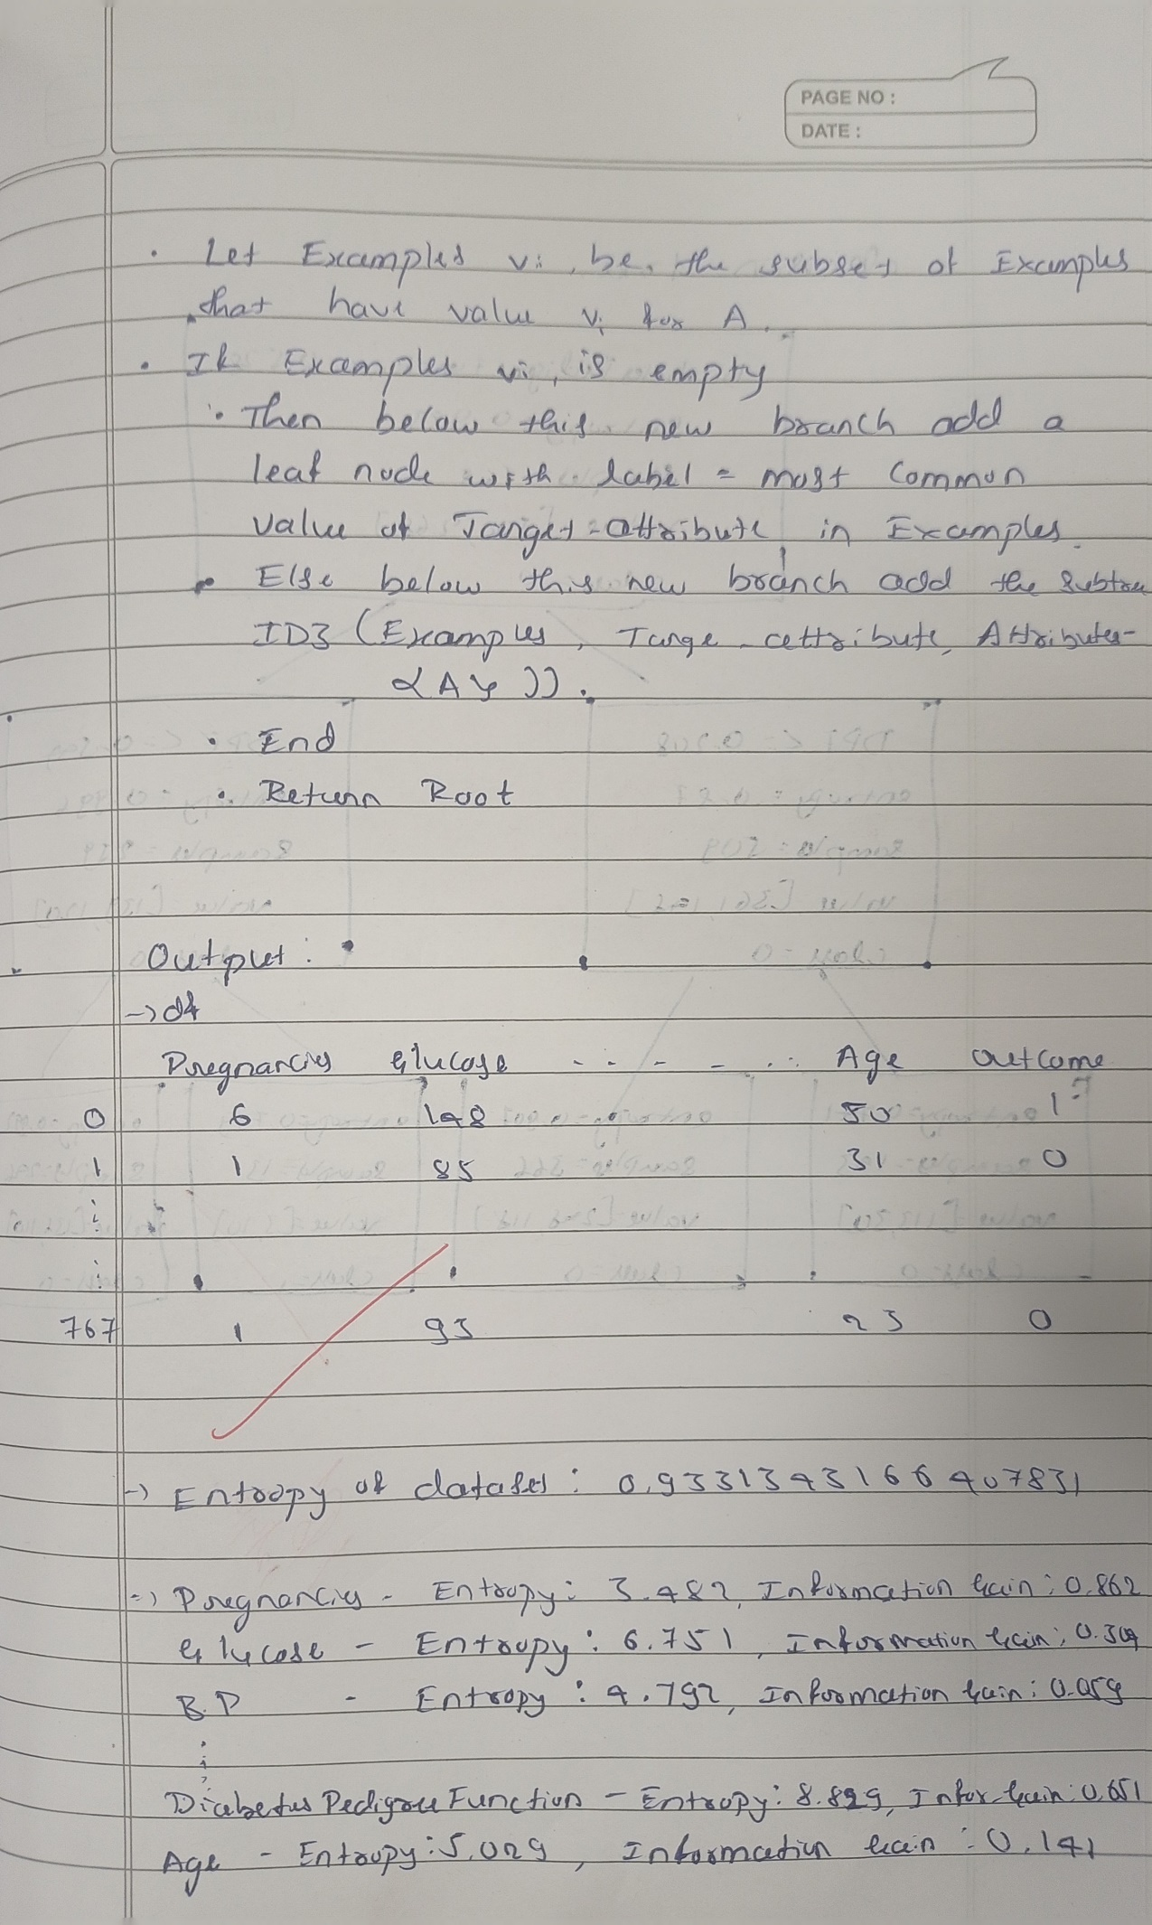

Code:

import pandas as pd

from sklearn.tree import DecisionTreeClassifier, plot_tree

import matplotlib.pyplot as plt

import math

df = pd.read_csv('/content/diabetes.csv')

df

def calculate_entropy(data, target_column):

total_rows = len(data)

target_values = data[target_column].unique()

entropy = 0

for value in target_values:

# Calculate the proportion of instances with the current value

value_count = len(data[data[target_column] == value])

proportion = value_count / total_rows

entropy -= proportion * math.log2(proportion)

return entropy

entropy_outcome = calculate_entropy(df, 'Outcome')

print(f"Entropy of the dataset: {entropy_outcome}")

def calculate_entropy(data, target_column): # for each categorical variable

total_rows = len(data)

target_values = data[target_column].unique()

entropy = 0

for value in target_values:

# Calculate the proportion of instances with the current value

value_count = len(data[data[target_column] == value])

proportion = value_count / total_rows

entropy -= proportion * math.log2(proportion) if proportion != 0 else 0

return entropy

def calculate_information_gain(data, feature, target_column):

# Calculate weighted average entropy for the feature

unique_values = data[feature].unique()

weighted_entropy = 0

for value in unique_values:

subset = data[data[feature] == value]

proportion = len(subset) / len(data)

weighted_entropy += proportion * calculate_entropy(subset, target_column)

# Calculate information gain

information_gain = entropy_outcome - weighted_entropy

return information_gain

for column in df.columns[:-1]:

entropy = calculate_entropy(df, column)

information_gain = calculate_information_gain(df, column, 'Outcome')

print(f"{column} - Entropy: {entropy:.3f}, Information Gain: {information_gain:.3f}")

# Feature selection for the first step in making decision tree

selected_feature = 'DiabetesPedigreeFunction'

# Create a decision tree

clf = DecisionTreeClassifier(criterion='entropy', max_depth=1)

X = df[[selected_feature]]

y = df['Outcome']

clf.fit(X, y)

plt.figure(figsize=(8, 6))

plot_tree(clf, feature_names=[selected_feature], class_names=['0', '1'], filled=True, rounded=True)

plt.show()

def id3(data, target_column, features):

if len(data[target_column].unique()) == 1:

return data[target_column].iloc[0]

if len(features) == 0:

return data[target_column].mode().iloc[0]

best_feature = max(features, key=lambda x: calculate_information_gain(data, x, target_column))

tree = {best_feature: {}}

features = [f for f in features if f != best_feature]

for value in data[best_feature].unique():

subset = data[data[best_feature] == value]

tree[best_feature][value] = id3(subset, target_column, features)

return tree

id3(df, 'Outcome', ['Pregnancies', 'Glucose', 'BloodPressure', 'SkinThickness', 'Insulin', 'BMI', 'DiabetesPedigreeFunction', 'Age'] )

Output:

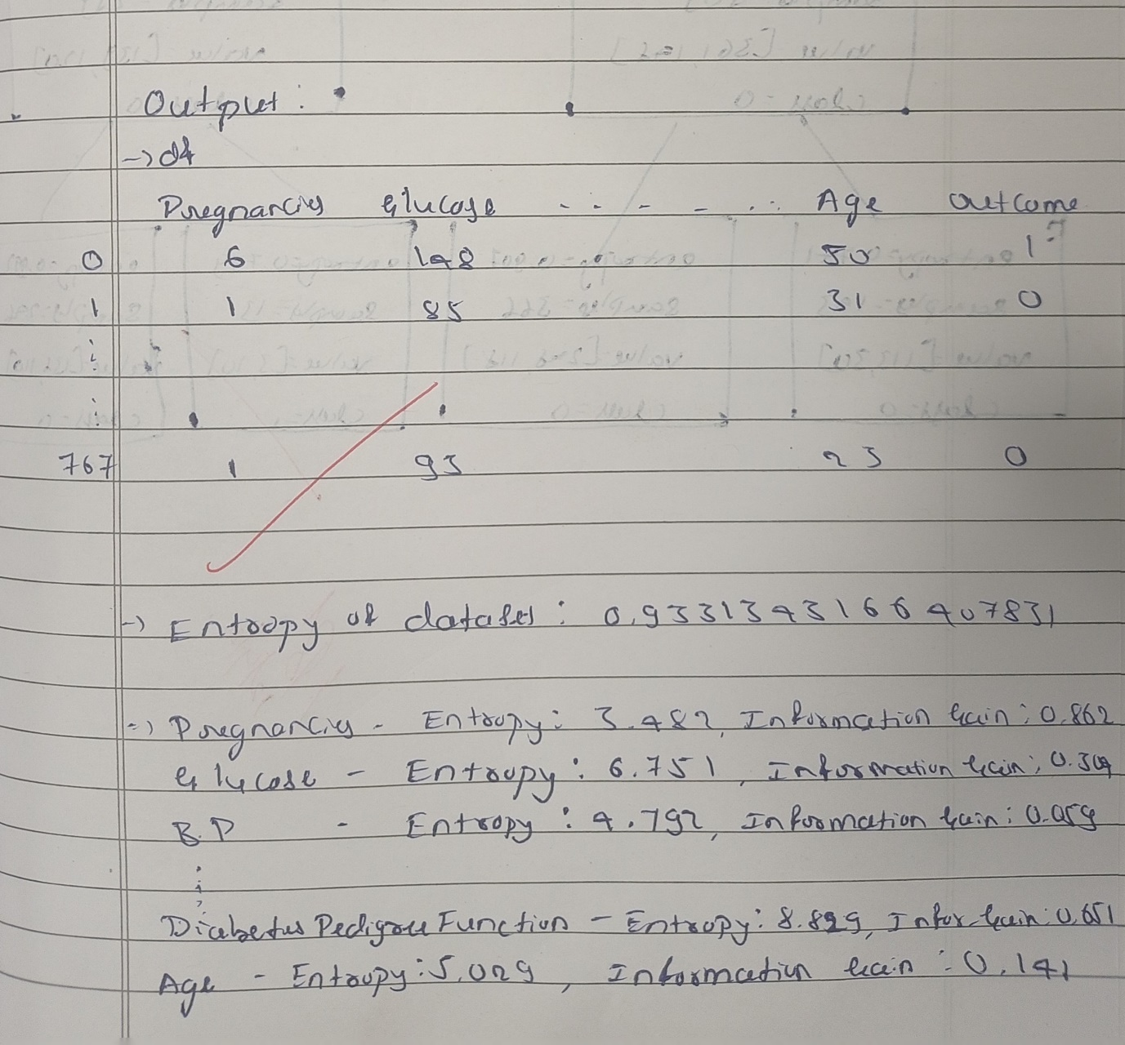

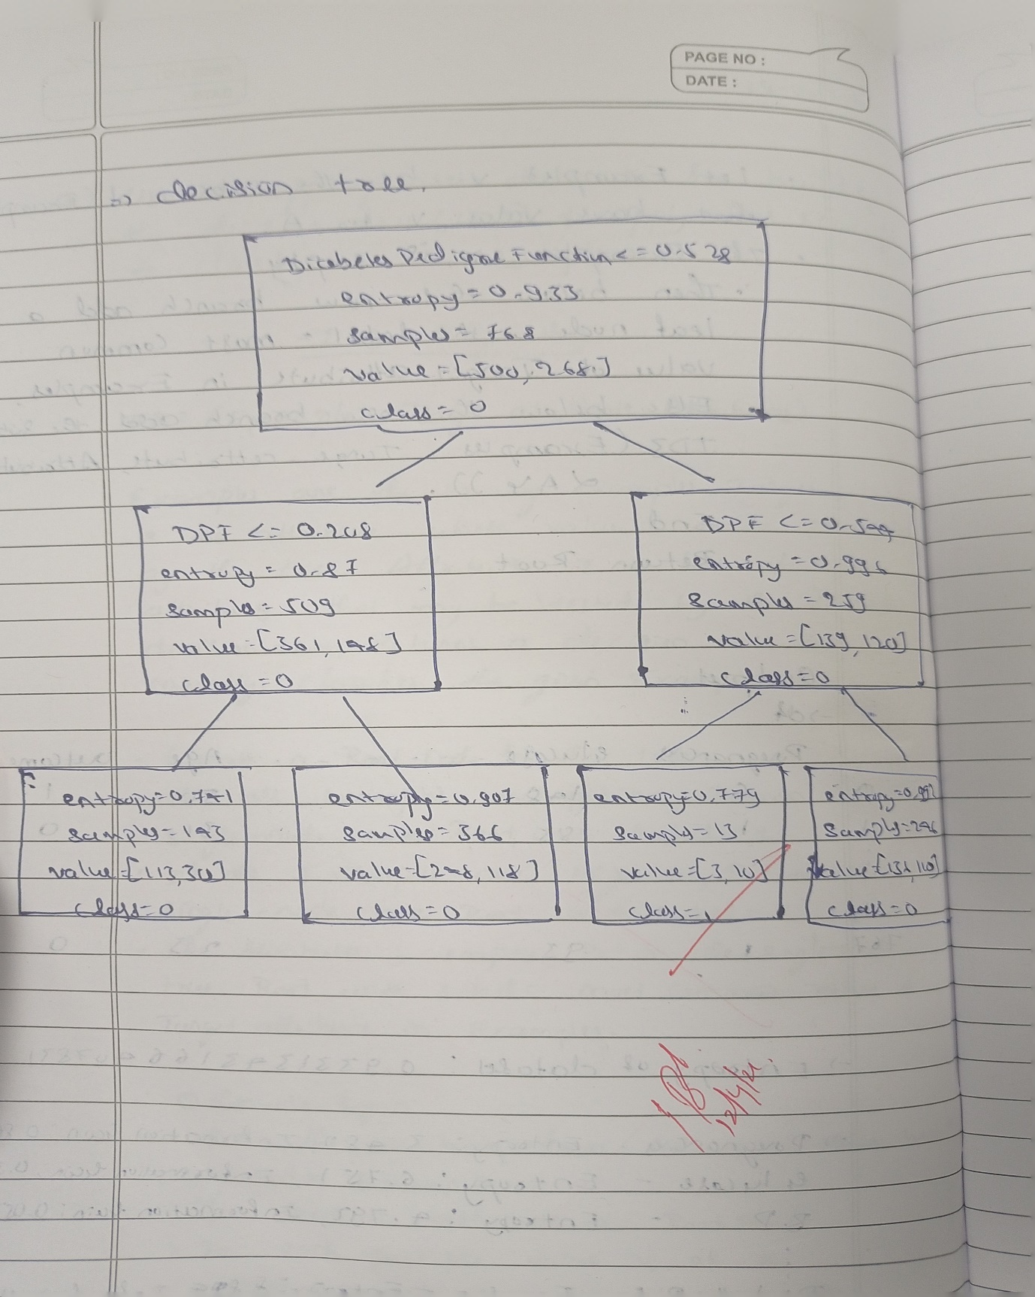

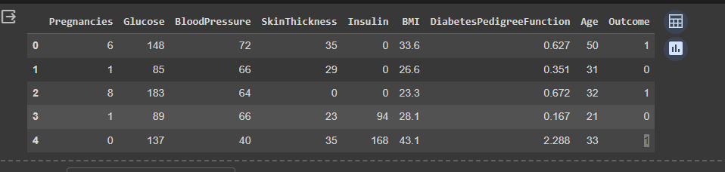

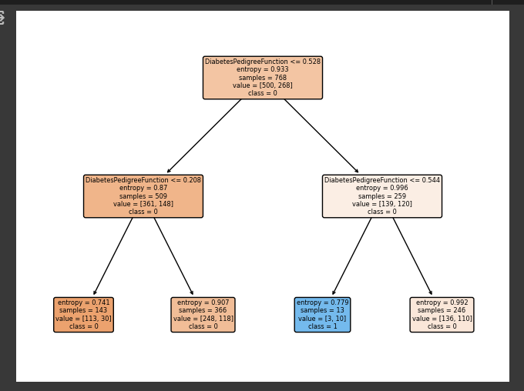

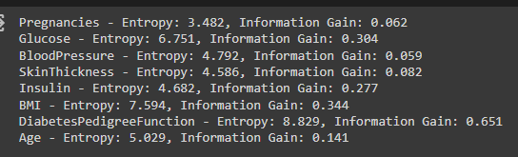

LAB-3

a**)Implement Linear Regression algorithm using appropriate dataset**

1. 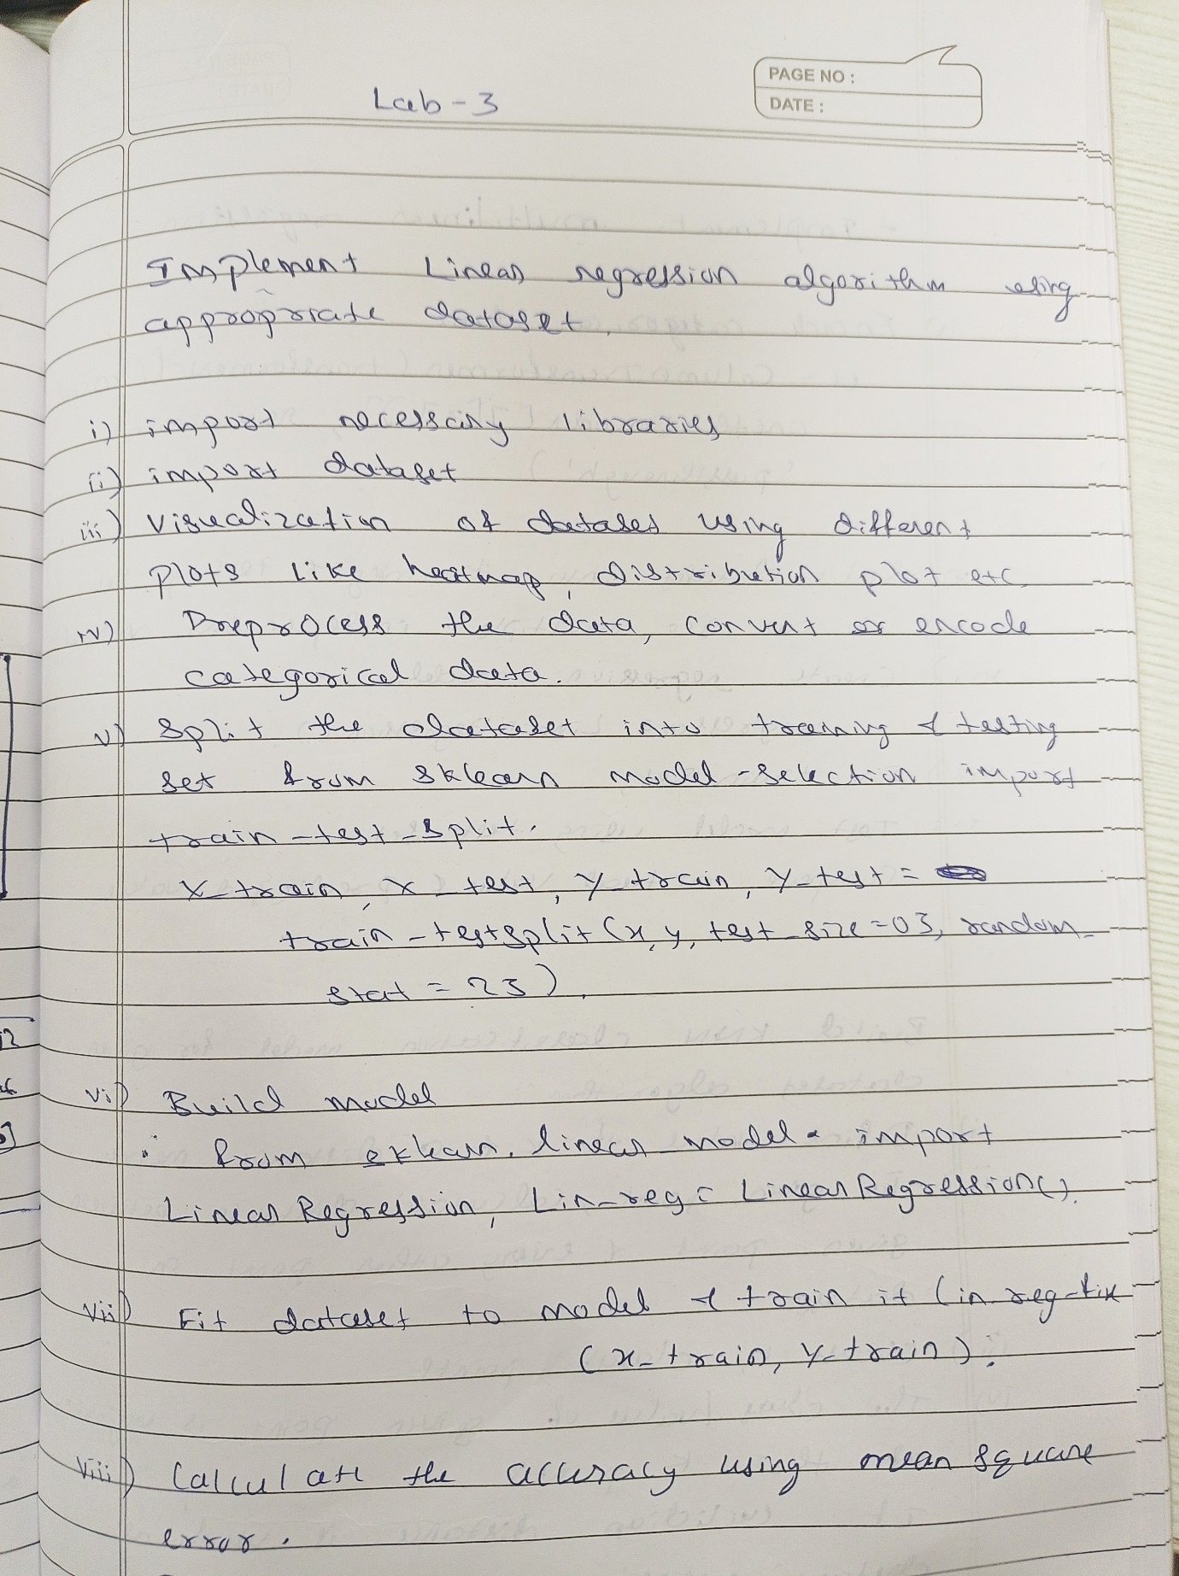

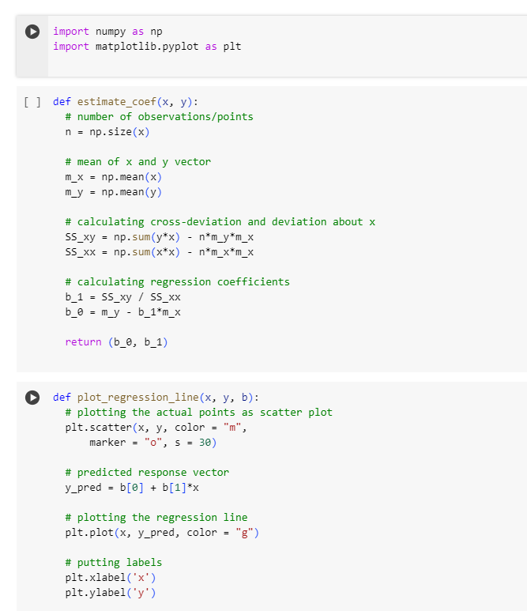

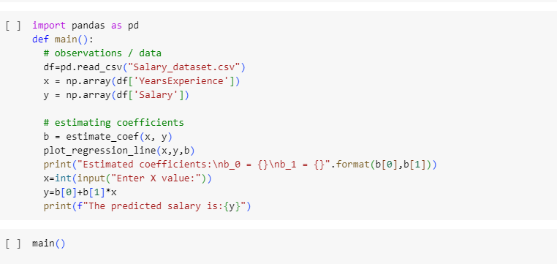

OUTPUT:

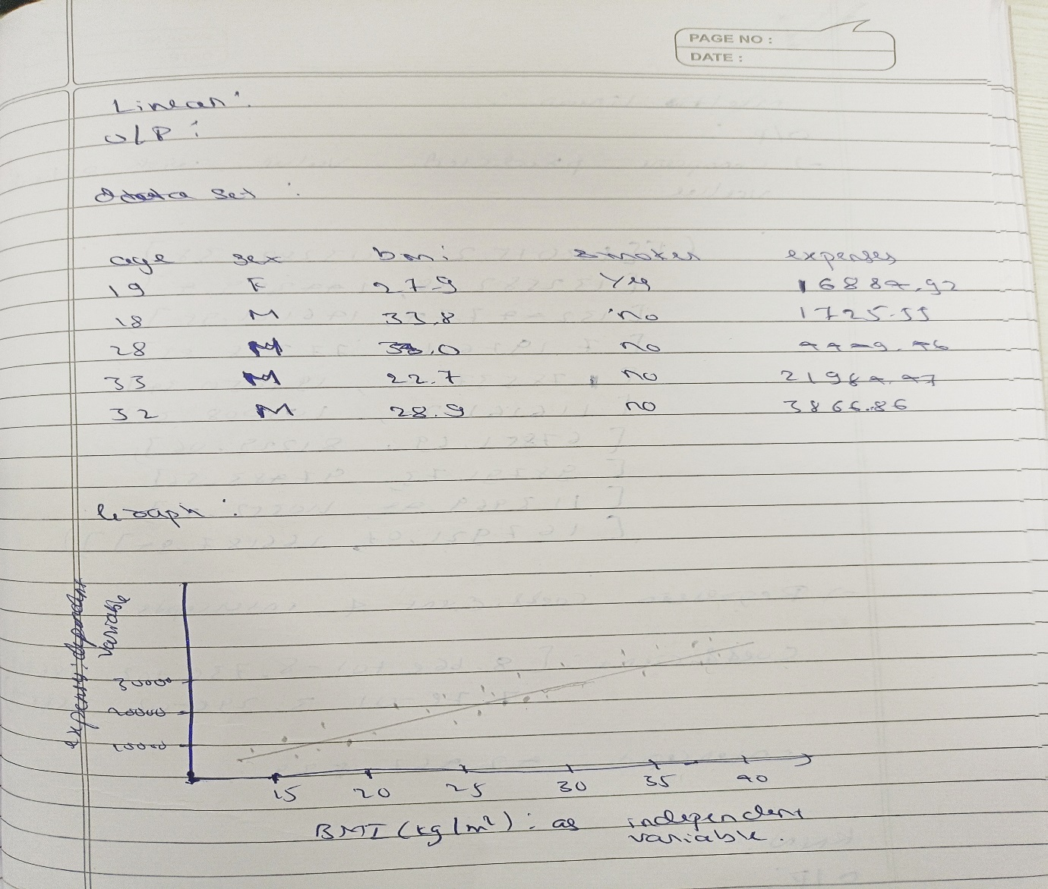

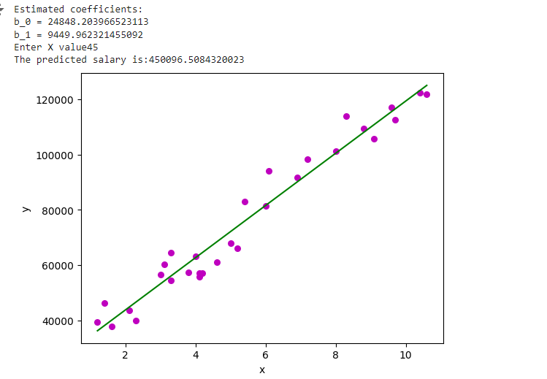

b)Implement Multi-Linear Regression algorithm using appropriate dataset

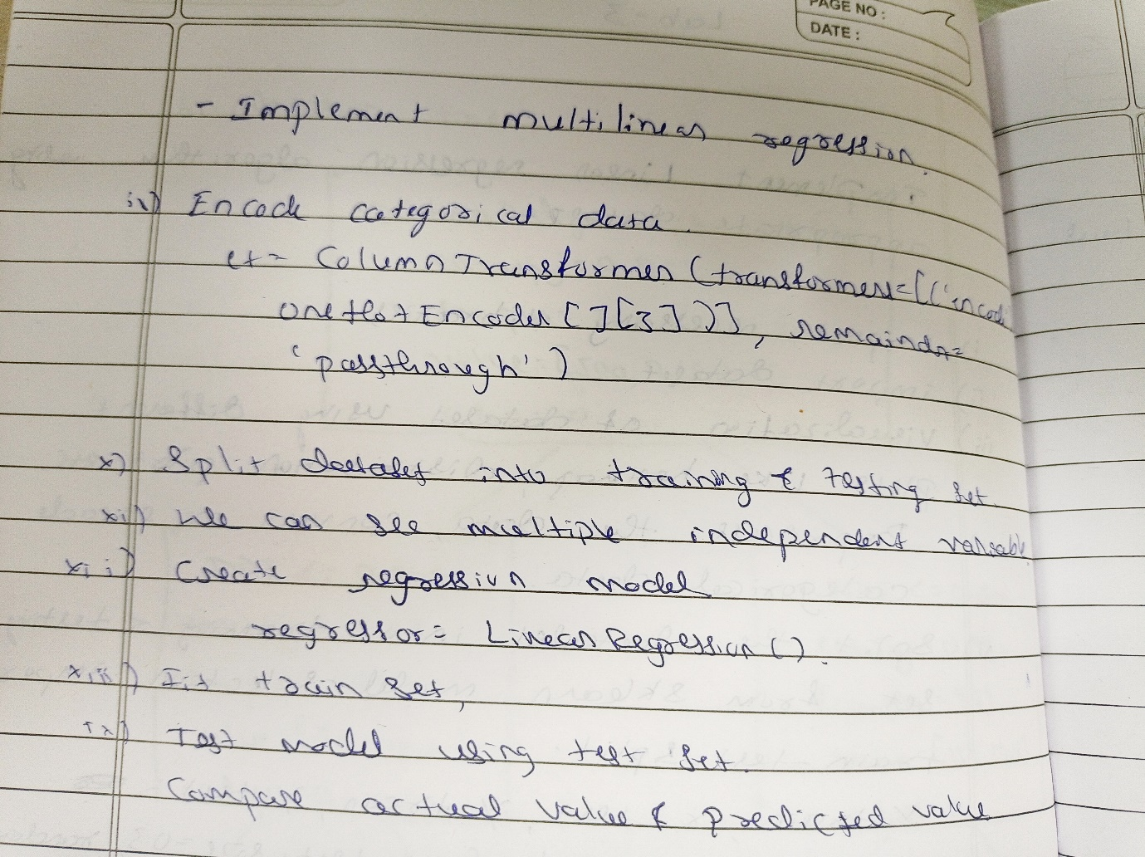

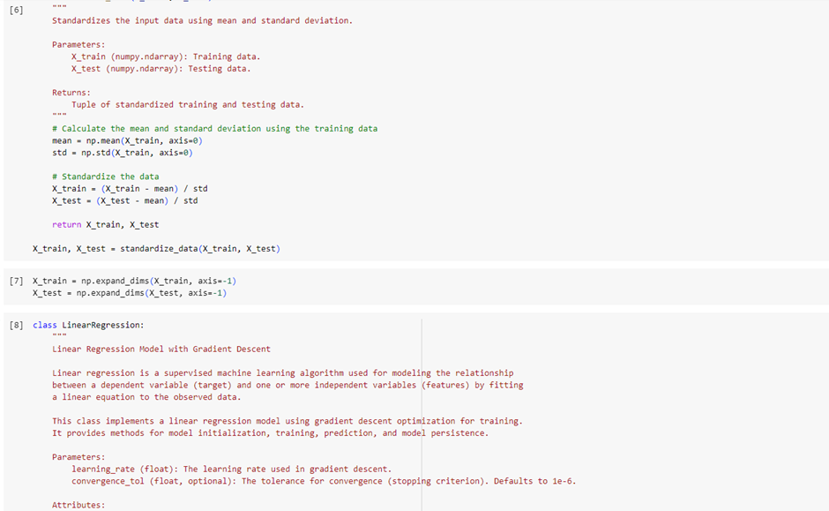

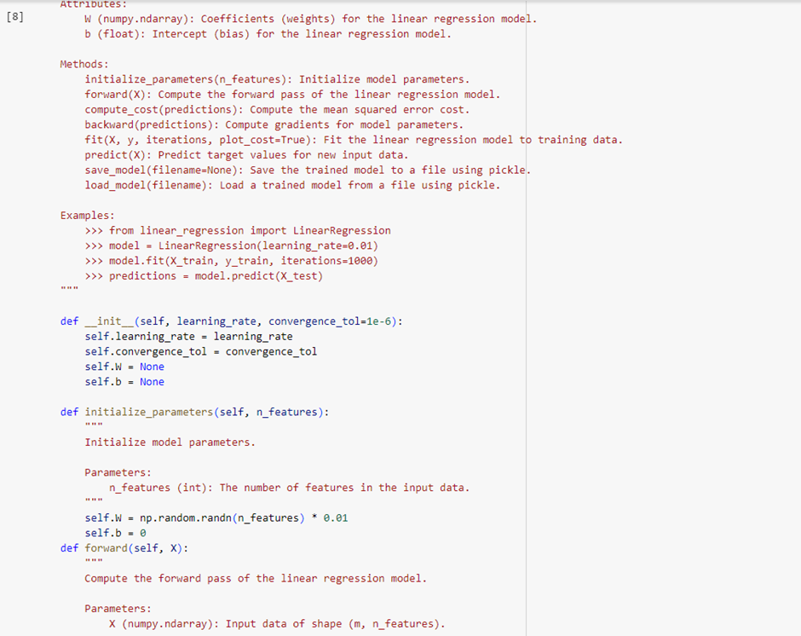

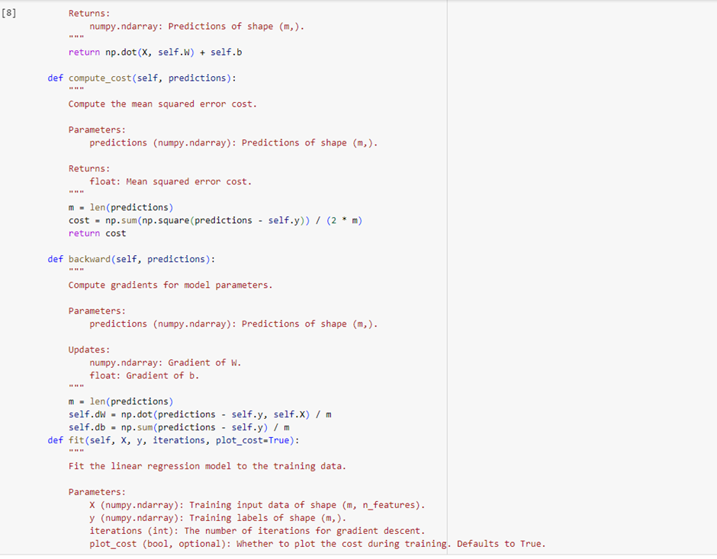

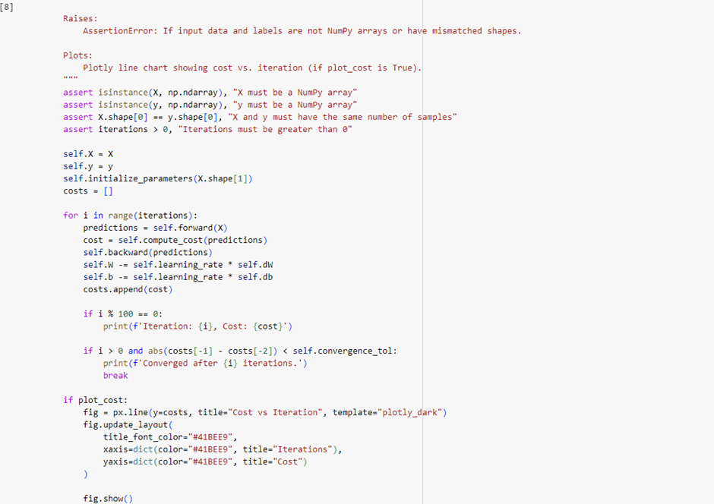

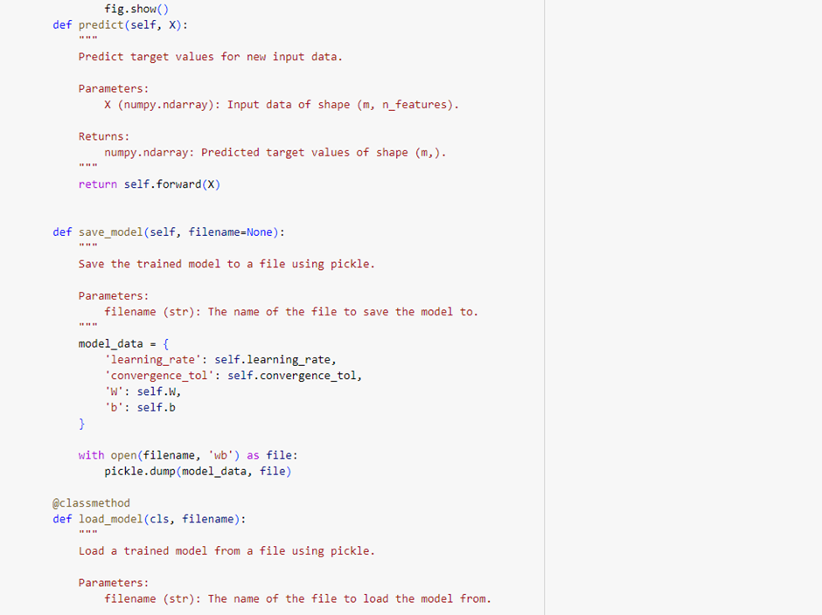

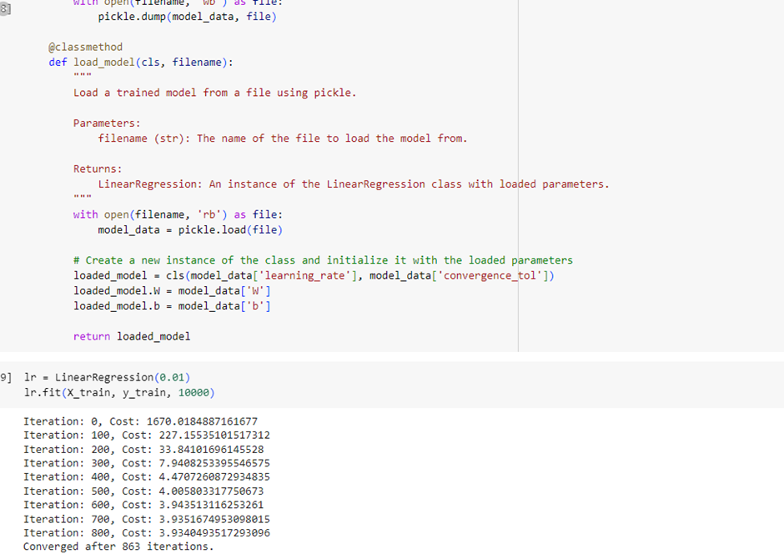

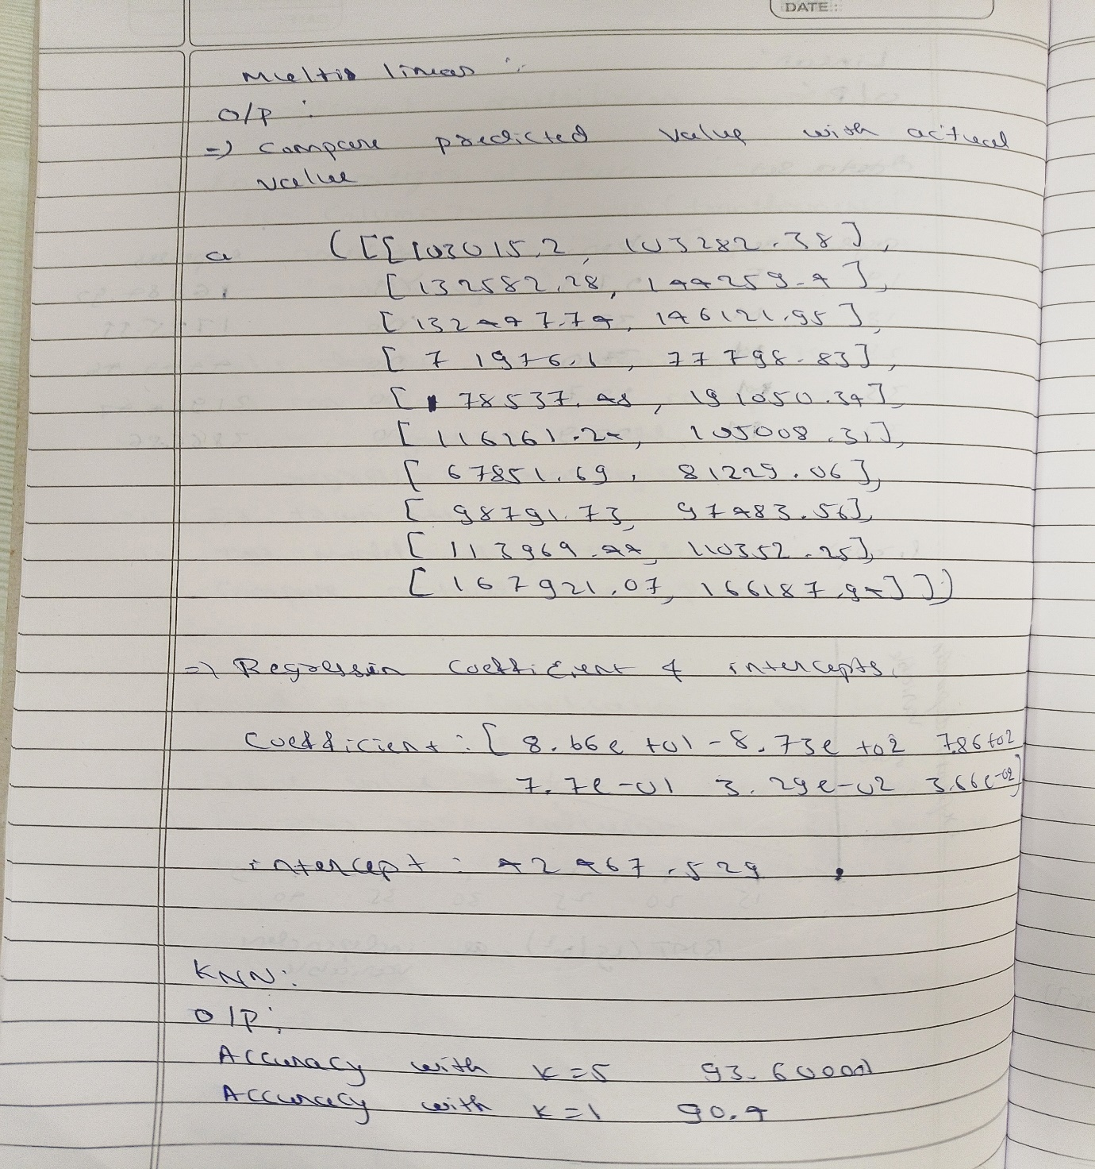

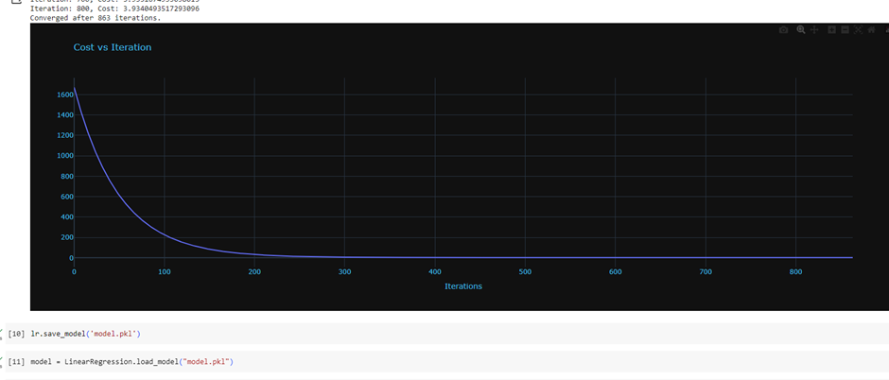

c)Build KNN Classification model for a given dataset.

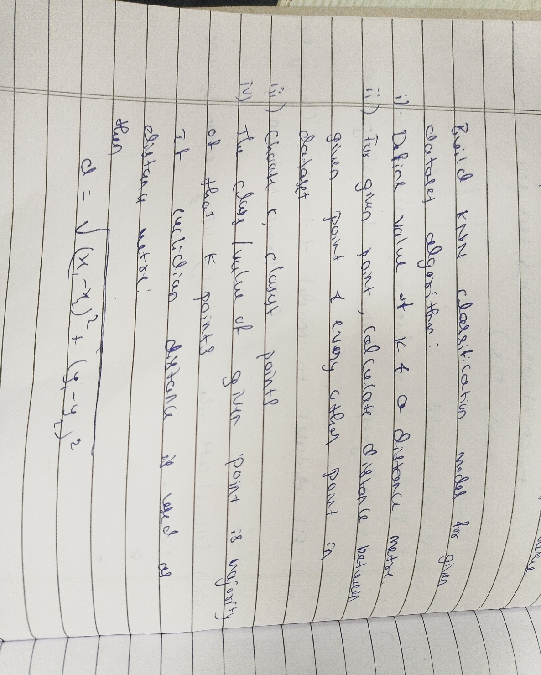

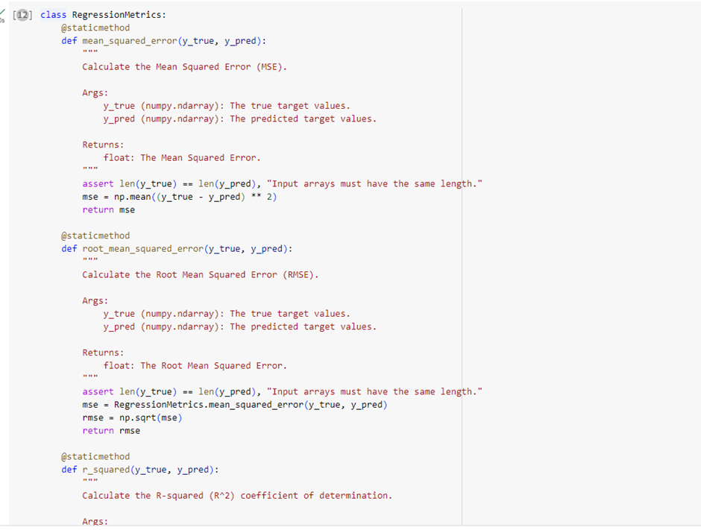

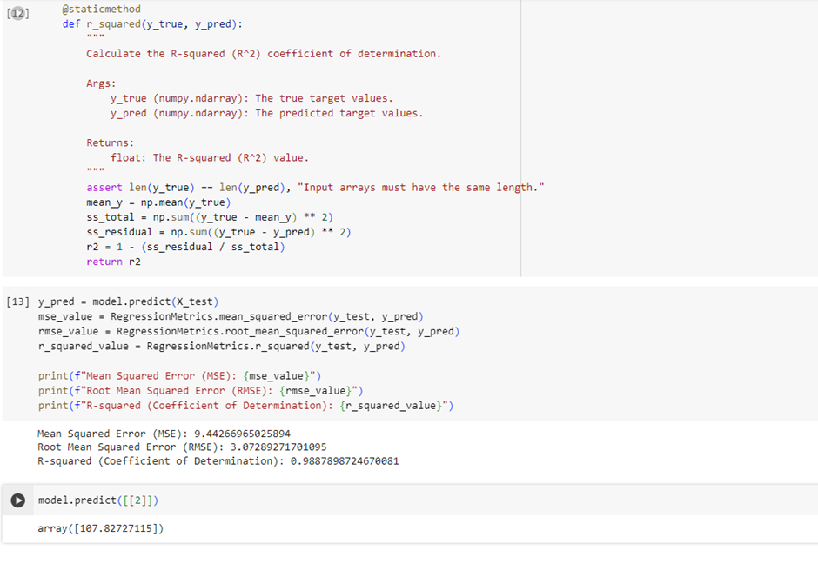

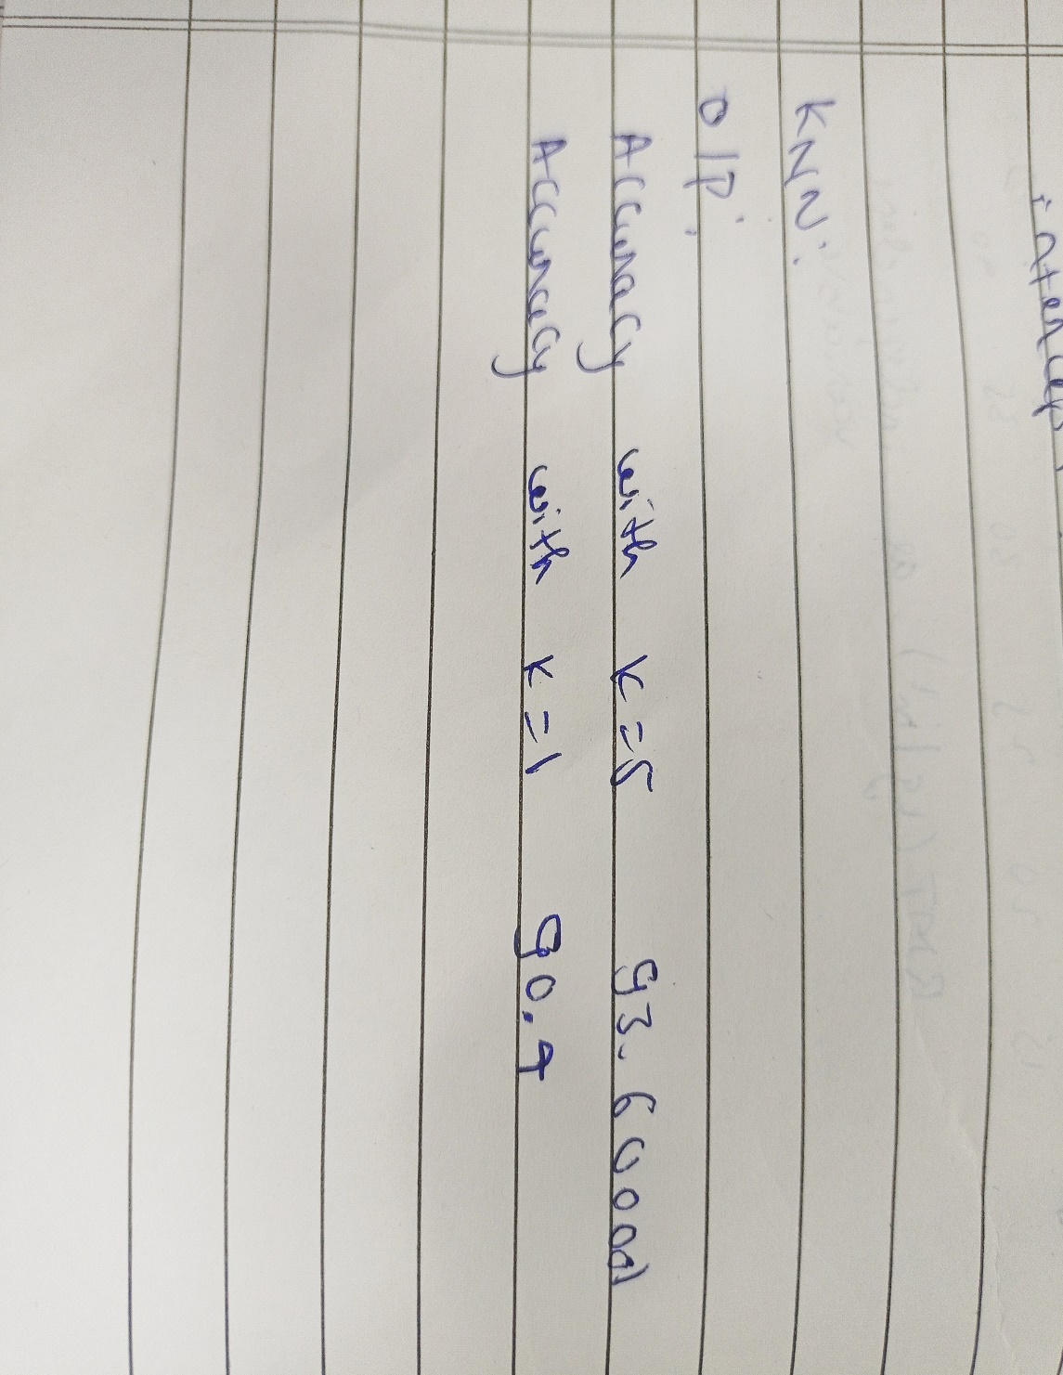

**Lab 4**

1. Build Logistic Regression Model for a given dataset

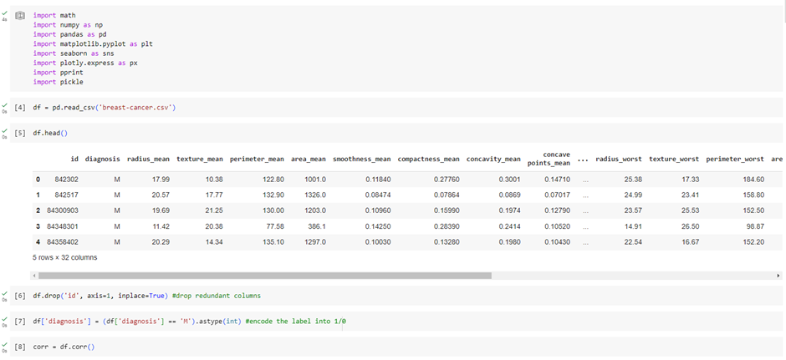

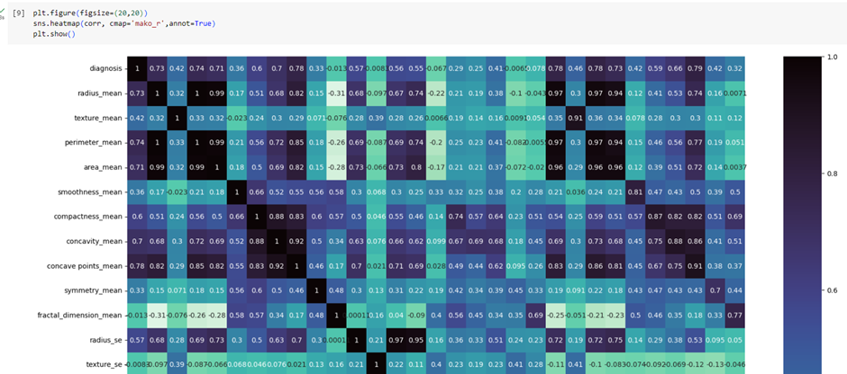

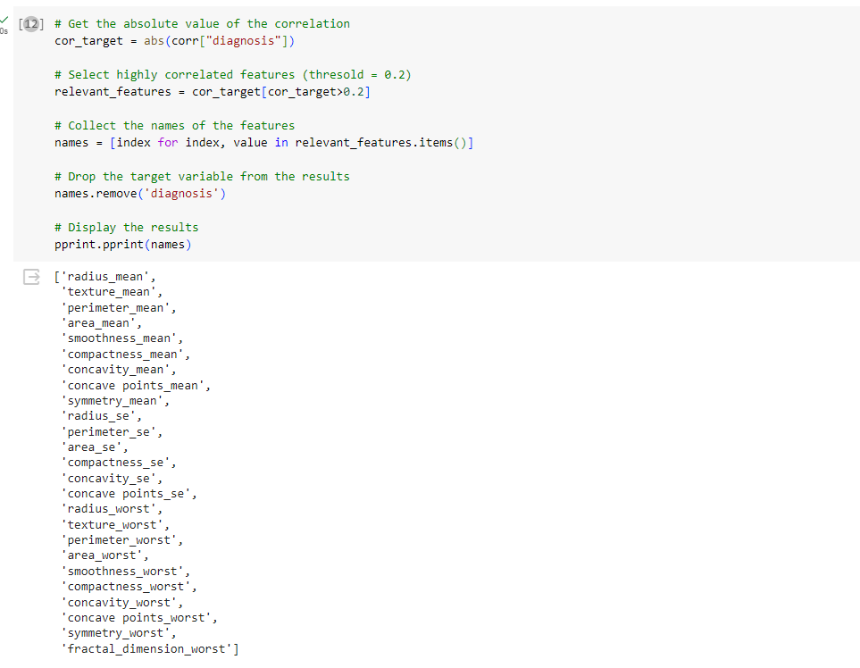

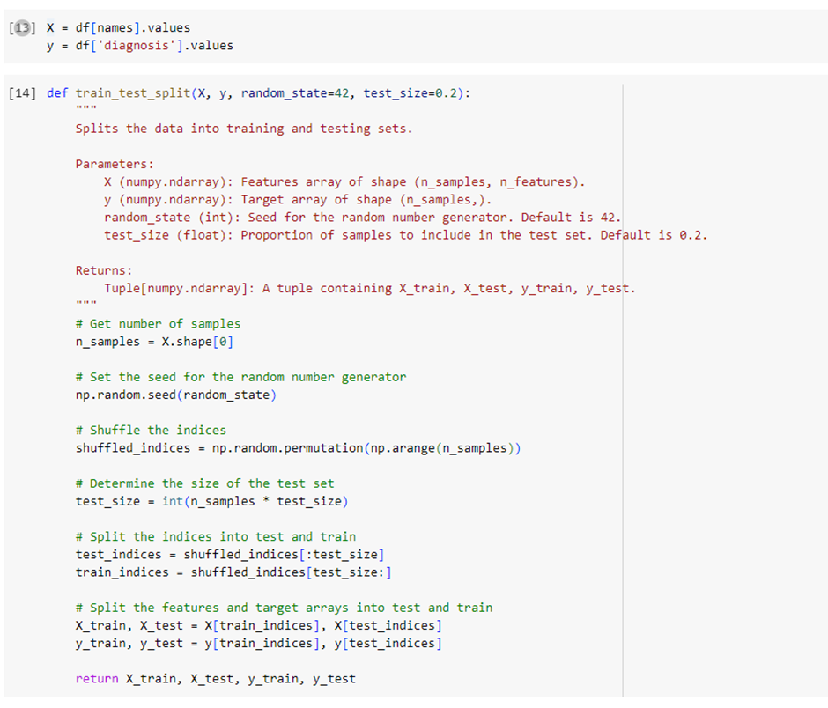

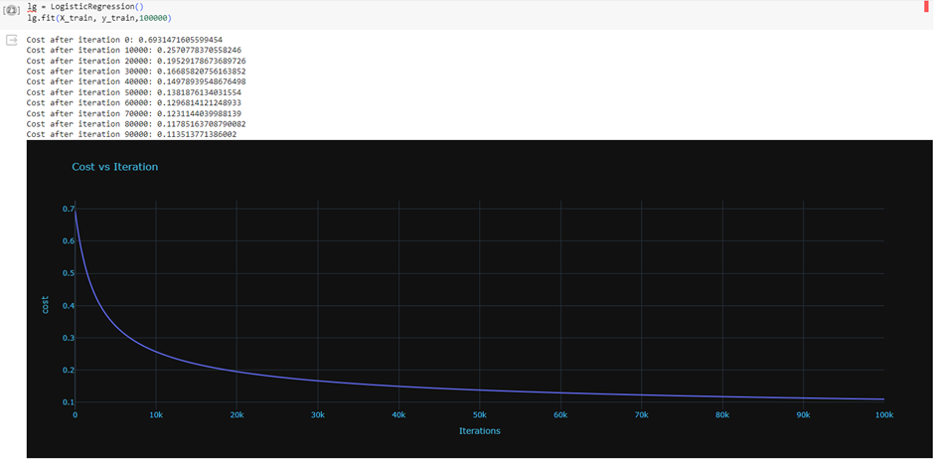

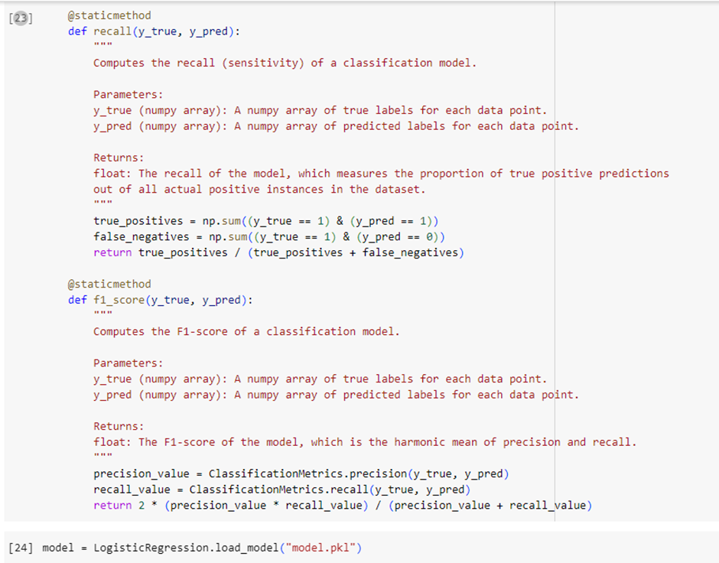

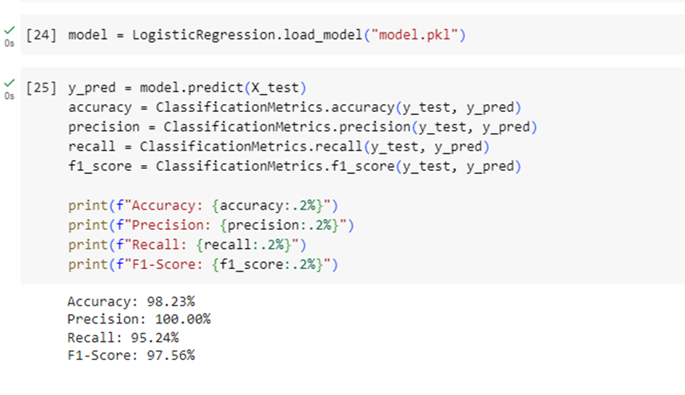

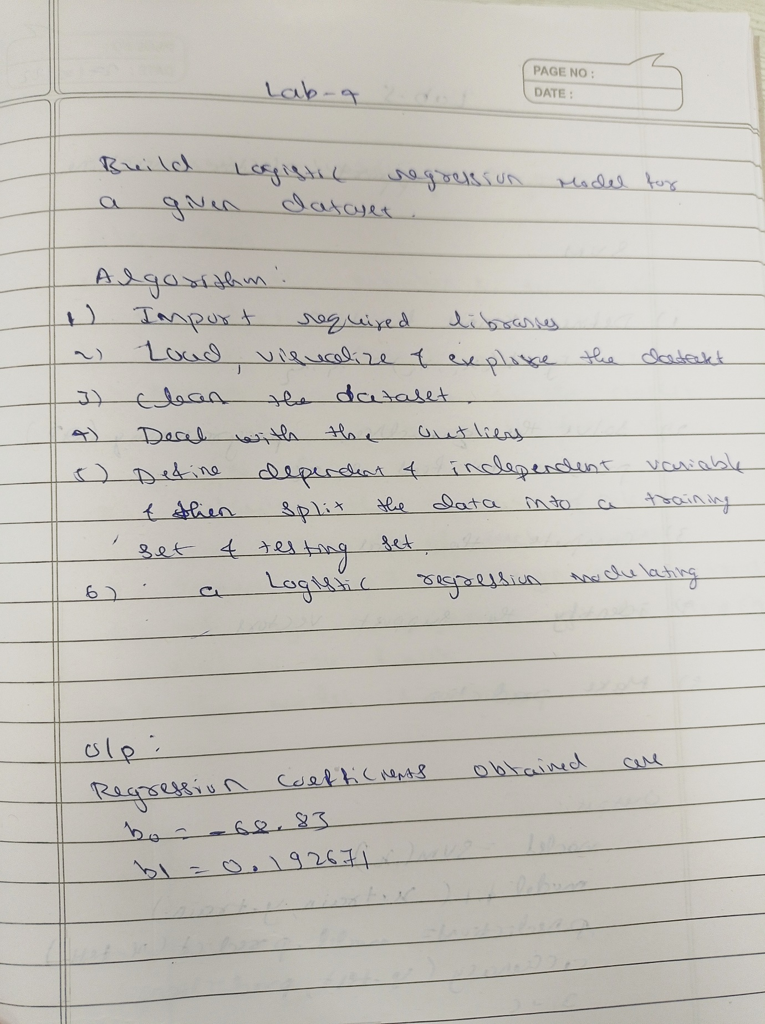

**LAB 5:**

**a)Build support vector machine for the dataset:**

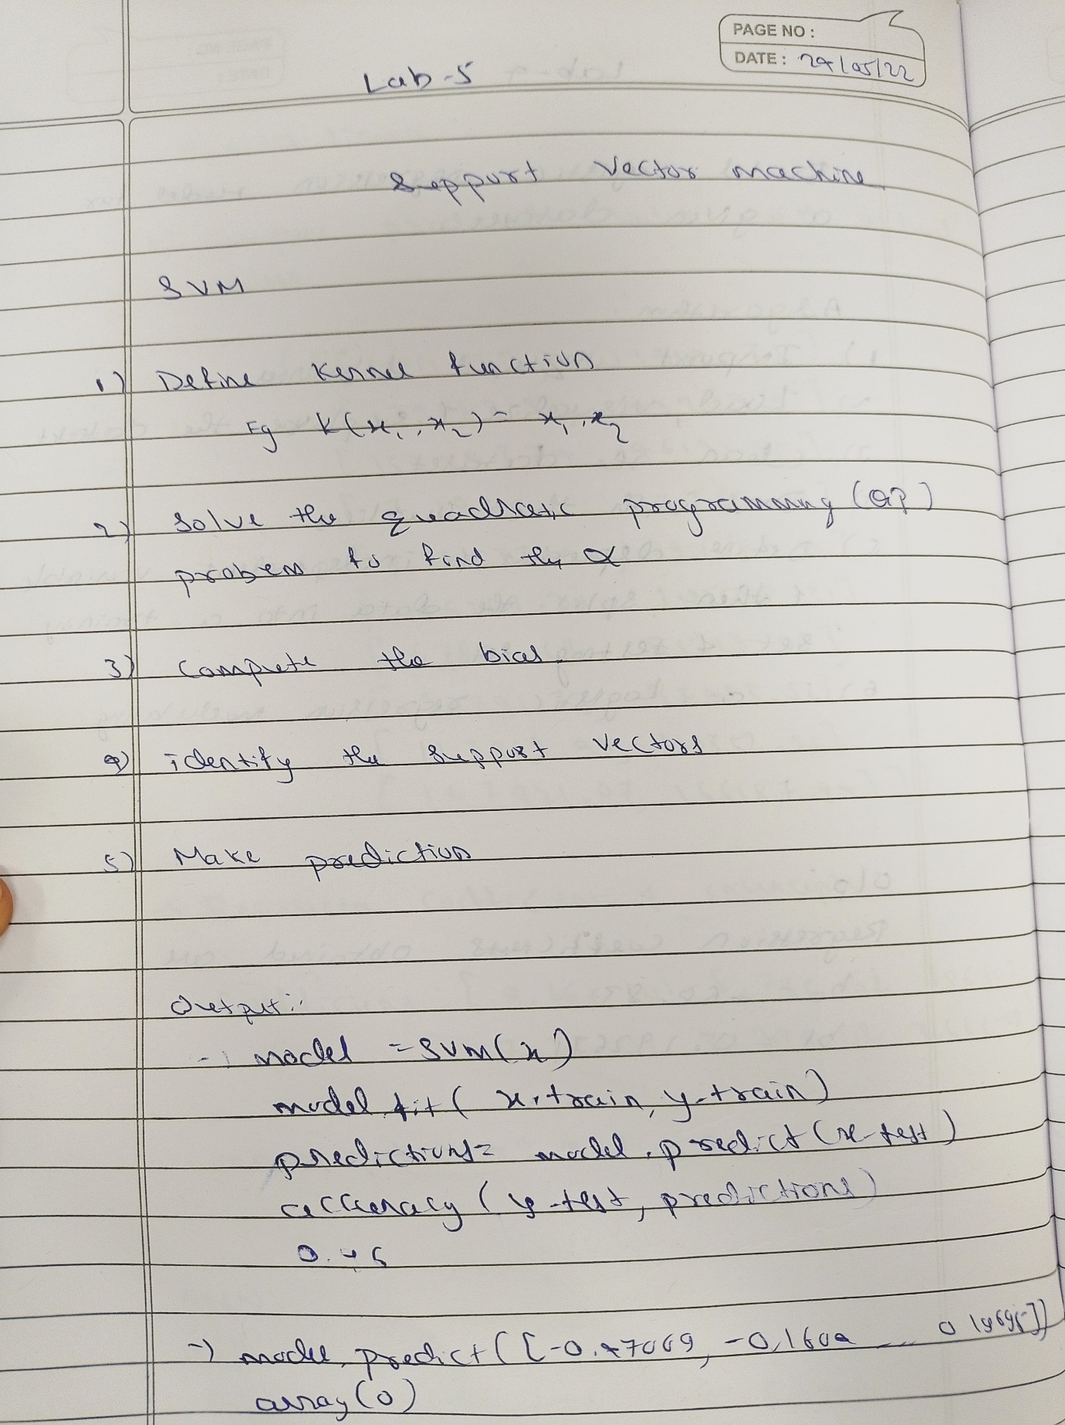

SVM:

**Code:**

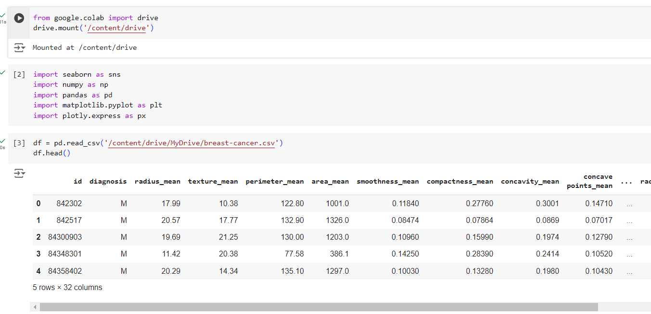

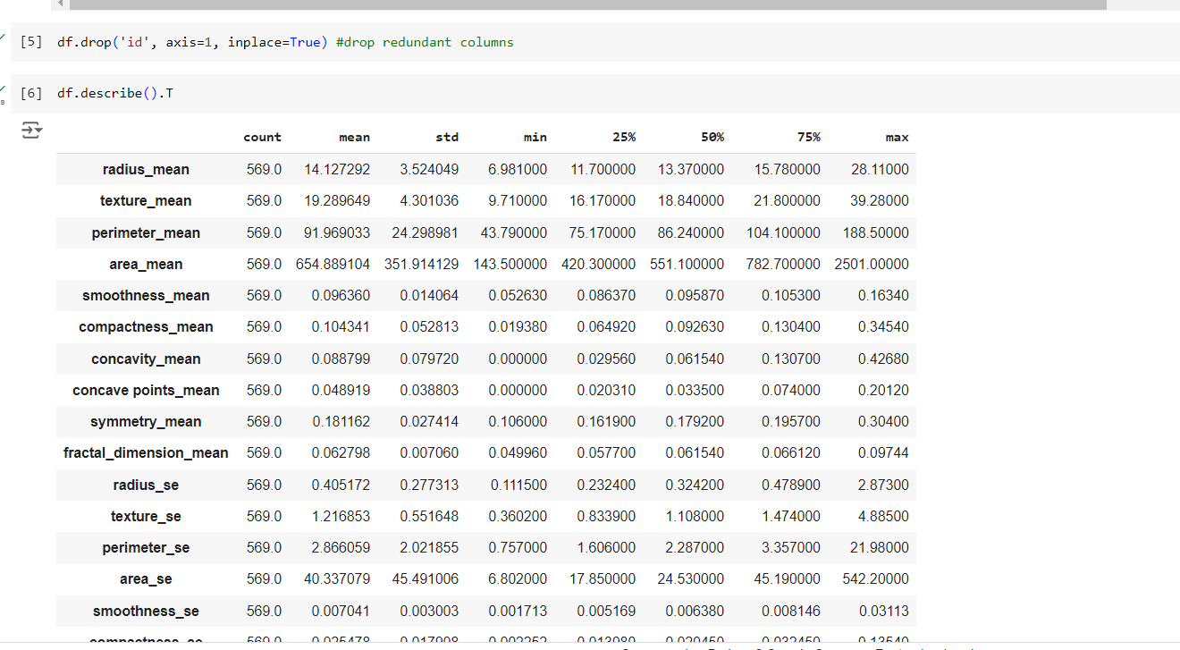

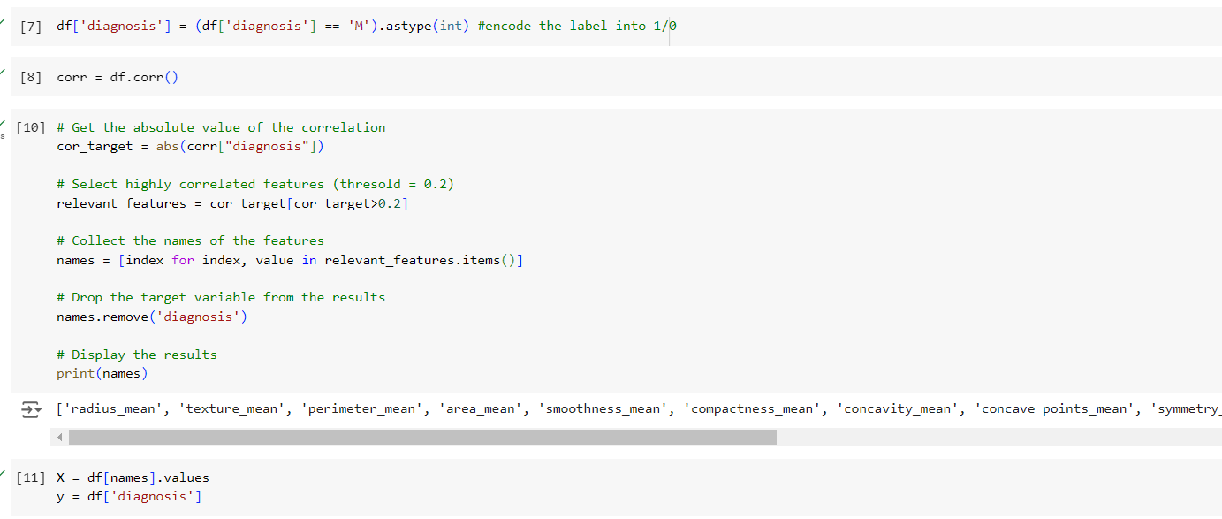

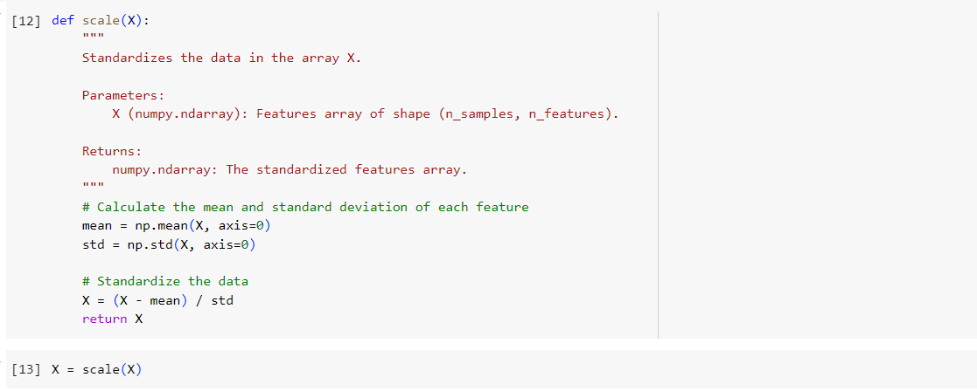

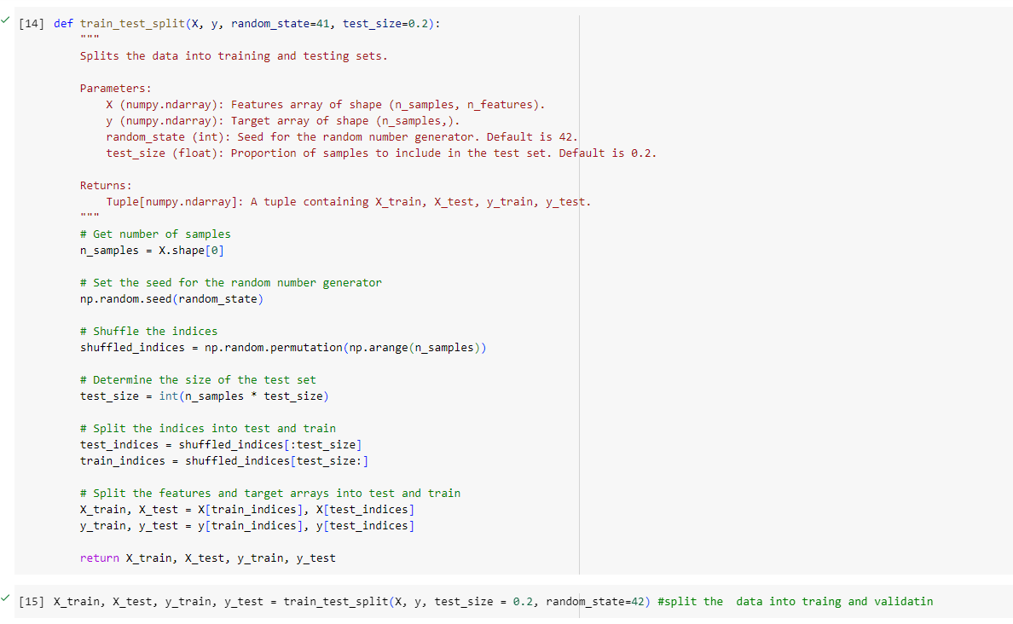

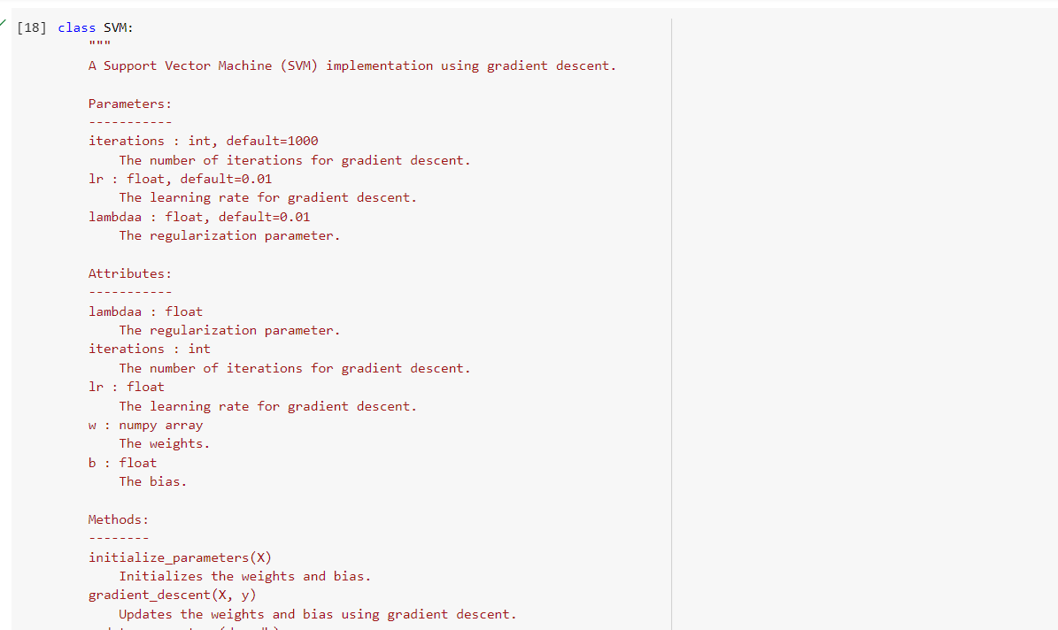

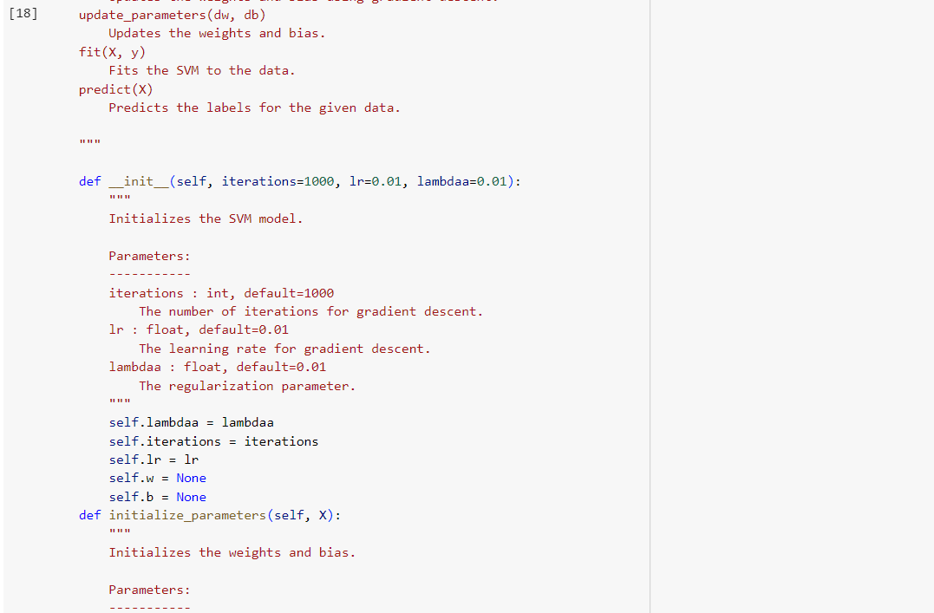

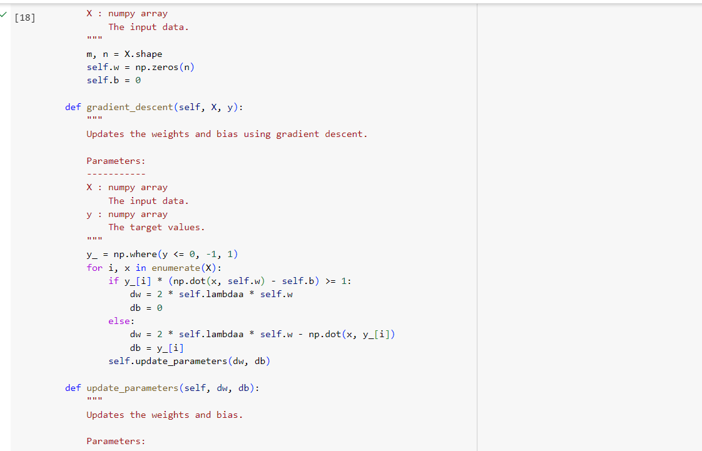

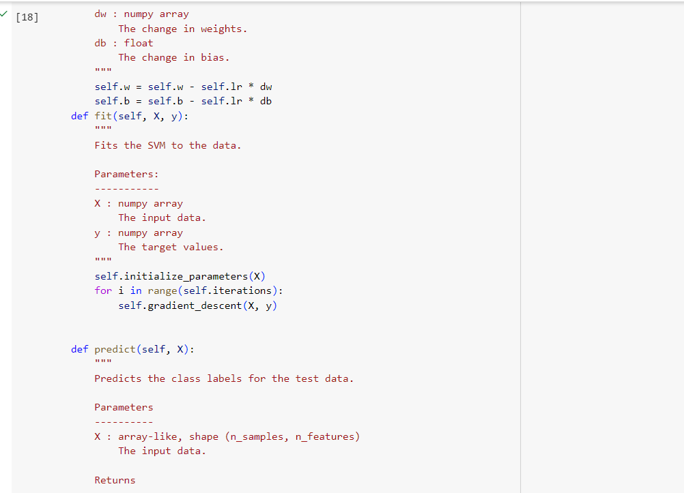

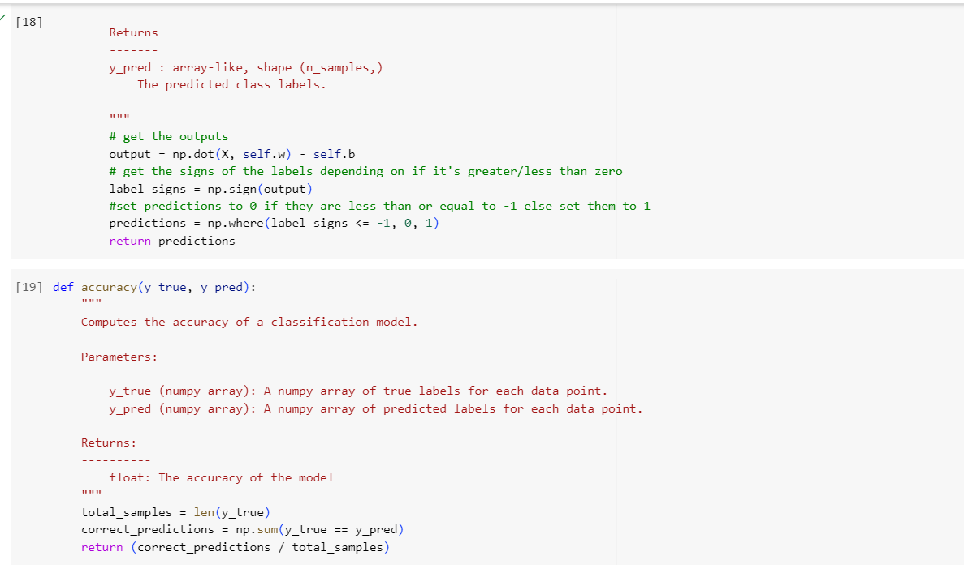

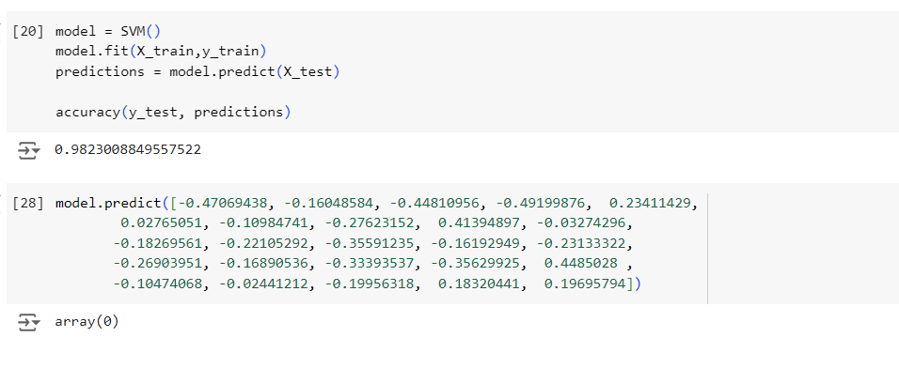

**b)K-MEANS Algorithm:**

**Code:**

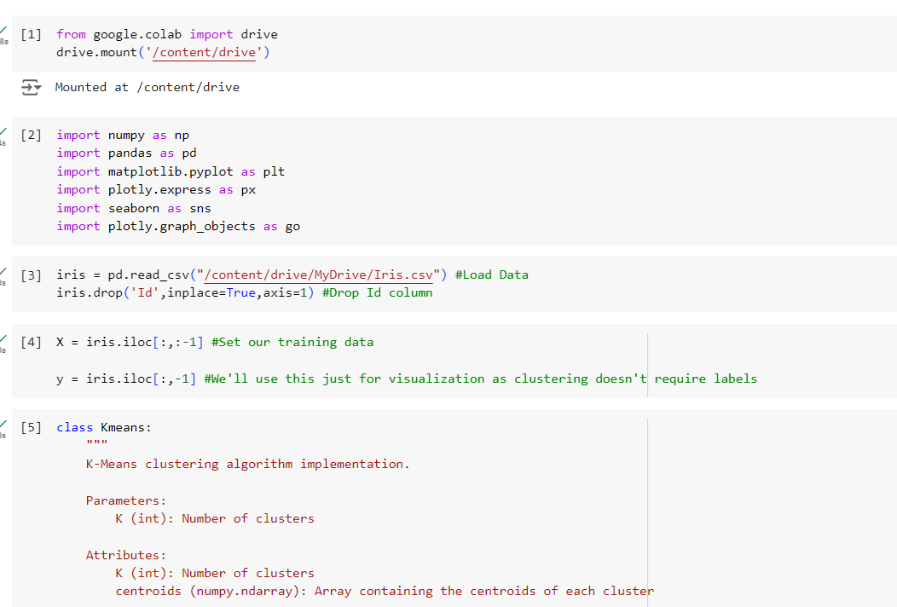

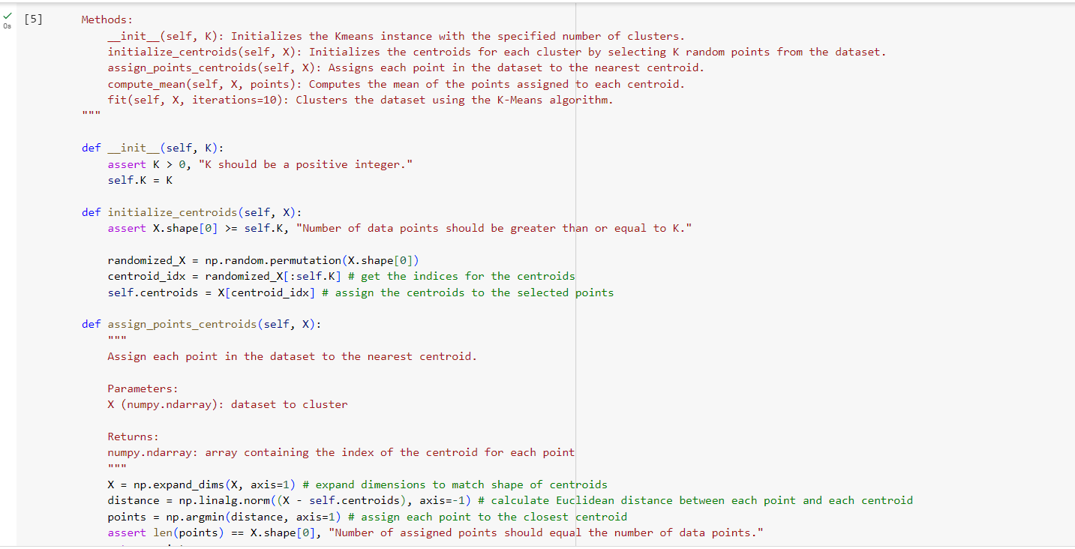

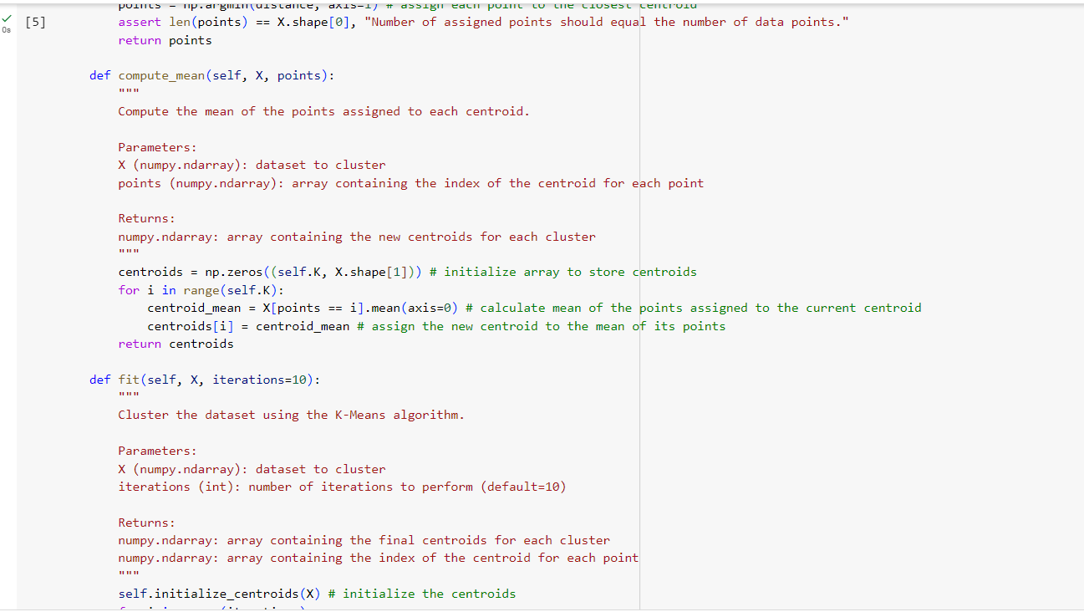

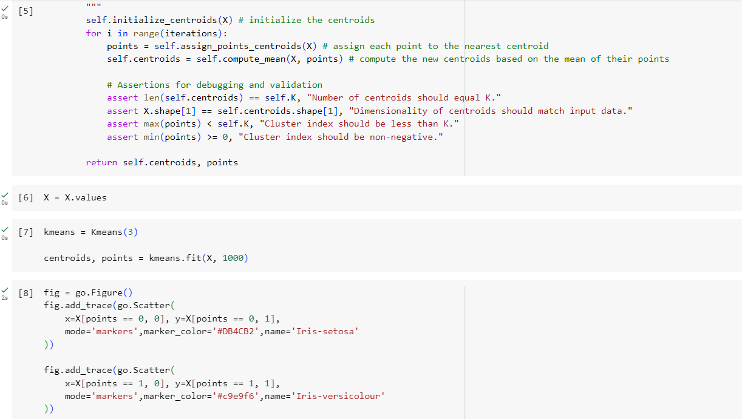

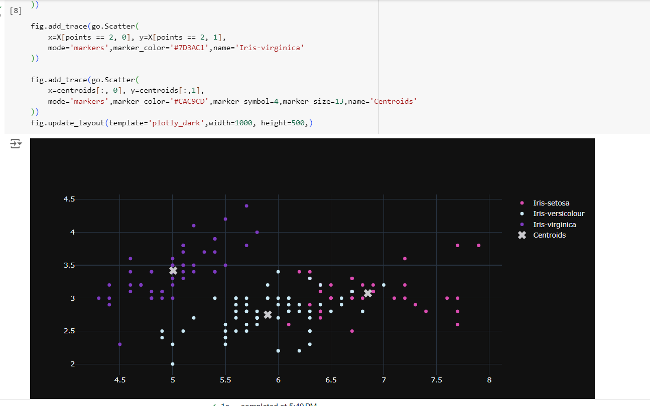

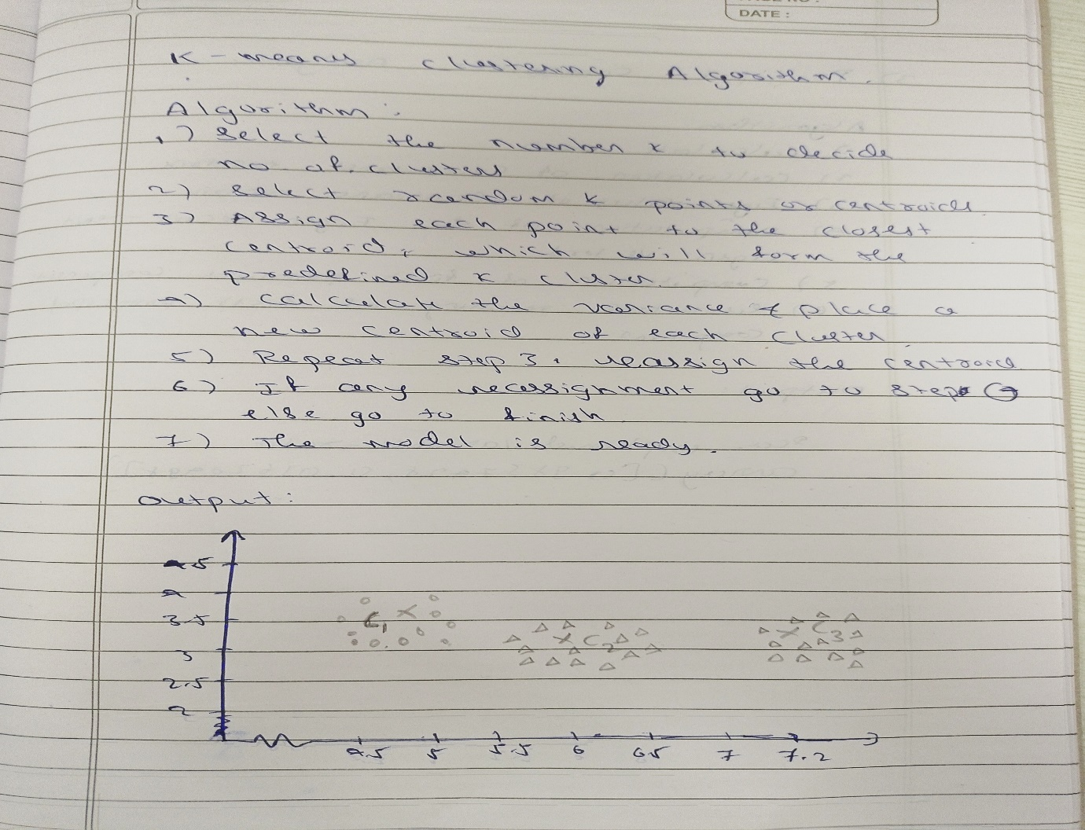

**c)Principal Component Analysis:**

**Code:**

